Problem Statement 7:

* I created an SQL server, and load the details from the server into my Data Studio.
* I set up a new Query on the SQL server to create my Database
* Using the Query on that Database, I created tables in the Database, defining parameters for the table like setting the primary keys and Foreign keys so as to create a relationship between the tables.
* I inserted data into each table and did a Join by joining different tables to query information such as FirstNmae, LastName, Address and Contact details.

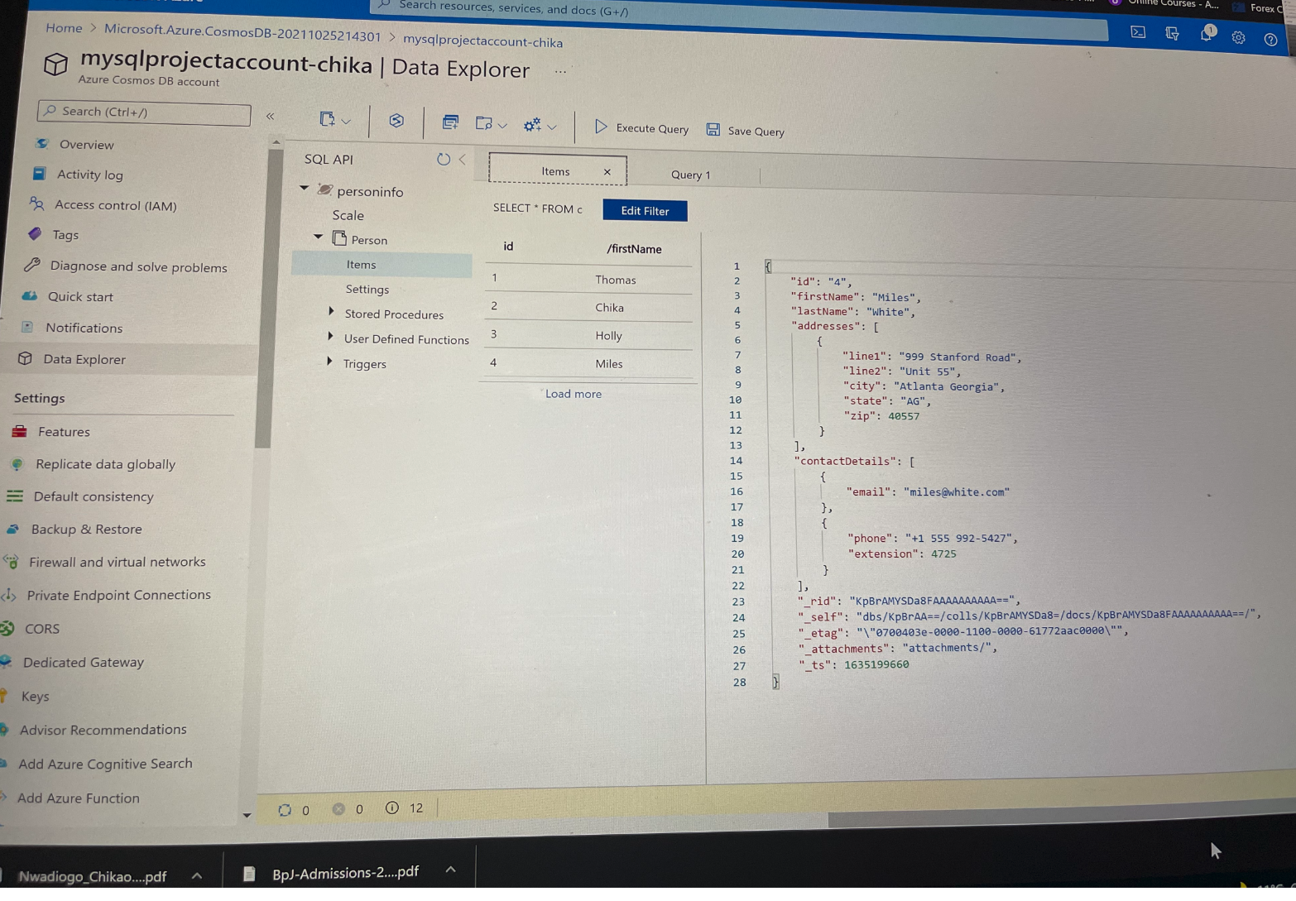

Figure 1: JSON documents for my items in Azure Cosmos DB